Coma-free alignment with CTF fits

From a CTF fit giving f₁, f₂, and astigmatism axis α, the defocus can be computed at any angle θ as
$0.5(f_{1} +f_{2}+\left(f_{1}- f_{2}\right)\cos\left(2\left(θ- α\right)\right))$
The coma-free alignment analysis works with three images taken at 0, -b_{m}, and +b_{m}, the beam tilt of measurement, along some axis of beam tilt. However, images can be taken over multiple changes by b_{m} to see how the defocus change depends on the beam tilt. It is observed that for any angle, the change in defocus between two images separated by a beam tilt of b_{m} is linearly related to the beam tilt midway between them. In the first graph below, the change in defocus at one angle for beam tilt changes of 4 mrad in X is plotted versus the midpoint between the two beam tilts, with the Y beam tilt constant at -8, -4, 0, +4, and +8 mrad. The relation is linear and the same slope is obtained for deflections in X regardless of the beam tilt in Y. The slope of this linear relationship is seen to be proportional to b_{m} itself. For example, if the same data are used to compute the slope between defocus changes of 8 mrad centered at -4 and +4 mrad, they give a slope of 0.58 instead of the slope of 0.29 seen in the graph. This means that the change in defocus from true 0 to any beam tilt is proportional to the square of beam tilt.
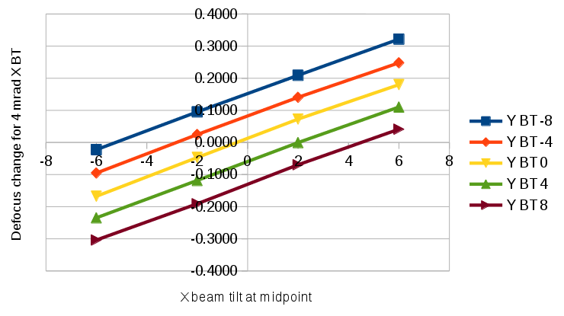
The linear relationship intercepts the X axis at the true zero of beam tilt, because changing beam tilt by equal amounts from that location will change defocus by equal amounts.

Let $∆f^{-}$ be the change in defocus at an angle going from -b_{m} to 0 and $∆f^{+}$ be the change going from 0 to +b_{m} . The slope of the line, S_{m}, can be estimated from the total difference in focus, divided by the distance between the midpoints of the two changes:
$$S_{m}=\frac{\left(∆f^{+}- ∆f^{-}\right)}{b_{m}}$$
The line with slope S_{m} passing through $\left(∆f^{-}, -b_{m}\right)$ is
$$∆f= ∆f^{-}+ S_{m }(b+\frac{b_{m}}{2})$$
This is zero at
$$∆f^{-}= {-S}_{m }\left(b_{0}+\frac{b_{m}}{2}\right)= {-S}_{m }b_{0}-(∆f^{+}- ∆f^{-})/2$$
Or
$$b_{0}= -\frac{∆f^{+}+ ∆f^{-}}{2S_{m }}$$
When there is imposed beam tilt only along the axis of misalignment (e.g., in X if b_{y0} is zero), then the defocus changes at all angles give very similar estimates of b₀ along that axis. This is shown by the blue squares in the next graph below, which are estimates of b_{x0} based on the defocus differences from -4 to 0 and 0 to 4 mrad in X with no Y beam tilt. The mean over all angles is 0.46 mrad and the SD is 0.03 mrad. In general, however, the estimated b_{x0} and b_{y0} oscillate substantially with angle, where the amplitude of oscillation depends on the size of b_{y0} and b_{x0}, respectively. This is shown by the red diamonds for a Y beam tilt of 4 mrad. It turns out that averaging over all angles separates these effects and gives an accurate estimate of the value for each axis. The average over the red curve is 0.25 mrad, surprising close to the estimate of b_{x0} with no Y beam tilt. It differs by only 5% of the applied beam tilt in Y, which implies that the estimate will be quite good when b_{y0} is much smaller.
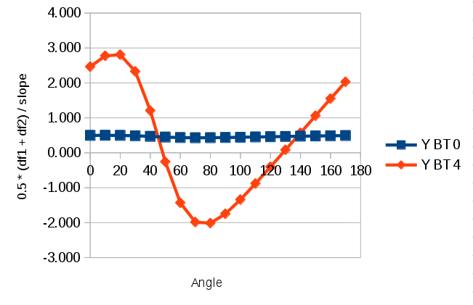
Two sets of image pairs at diagonal imposed beam tilts can be analyzed similarly to give estimates of b_{u0} and b_{v0}, where u and v are the axes at 45° and 135°, respectively. This yields an independent estimate of the beam tilt from
$$b_{x0}=\left(b_{u0}- b_{v0}\right)/\sqrt{2}$$
$$b_{y0}=\left(b_{u0}+ b_{v0}\right)/\sqrt{2}$$
The program simply averages these with the estimates from the beam tilts in just X or Y.
The downfall of the method is that it is sensitive to focus/Z-height changes within the set of images.

